**DAILY ONLINE ACTIVITIES SUMMARY**

|  |  |  |  |
| --- | --- | --- | --- |
| **Date:** | 13/06/2020 | **Name:** | Krishnitha |
| **Sem & Sec** | 4th sem, A Section | **USN:** | 4AL18CS039 |
| **Online Test Summary** | | | |
| **Subject** | Data Communication | | |
| **Max. Marks** | 30 | **Score** | 15 |
| **Certification Course Summary** | | | |
| **Course** | 1) Blockchain [Ethereum]workshop  2) Application Developer | | |
| **Certificate Provider** | 1) Emurgo Academy  2) AWS Educate | **Duration:** | 1)1.30 hrs.  2)2 hrs. |
| **Coding Challenges** | | | |
| **Problem Statement:**  1) Write a C Program to calculate Electricity Bill.  2) Write a program to find the first non-repeated character of a given String. | | | |
| **Status:** Executed | | | |
| **Uploaded the report in GitHub** | | YES | |
| **If yes Repository name** | | <https://github.com/krishnitha/Java-coding>  <https://github.com/krishnitha/C-coding> | |
| **Uploaded the report in slack** | | YES | |

**Online Test Details:**

Today we had assessment in the subject Data Communication. The test was based on first and second module of this subject. Test was comprised of total 30 questions of one mark each, out of which I scored 13.

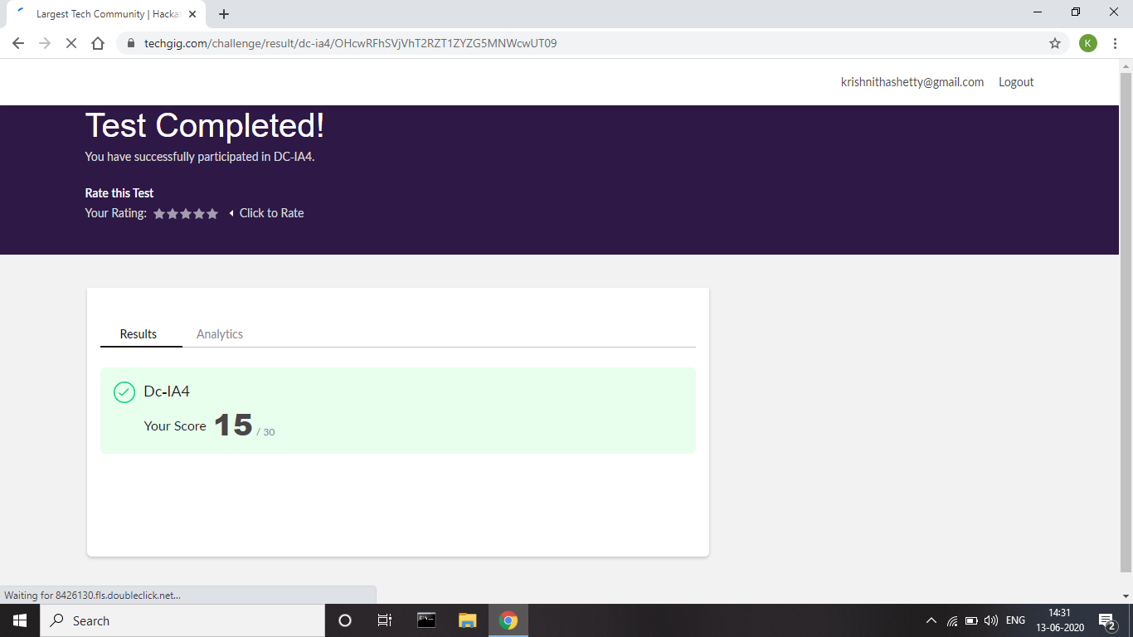

**Certification Course Details:**

Today I have attended a webinar on “Unchain Ethereum and its Potential” by Emurgo Academy. This webinar was very interesting. I learnt about the potential of Ethereum in various domains such as Business, Gaming, Animation and also some real-world domains.

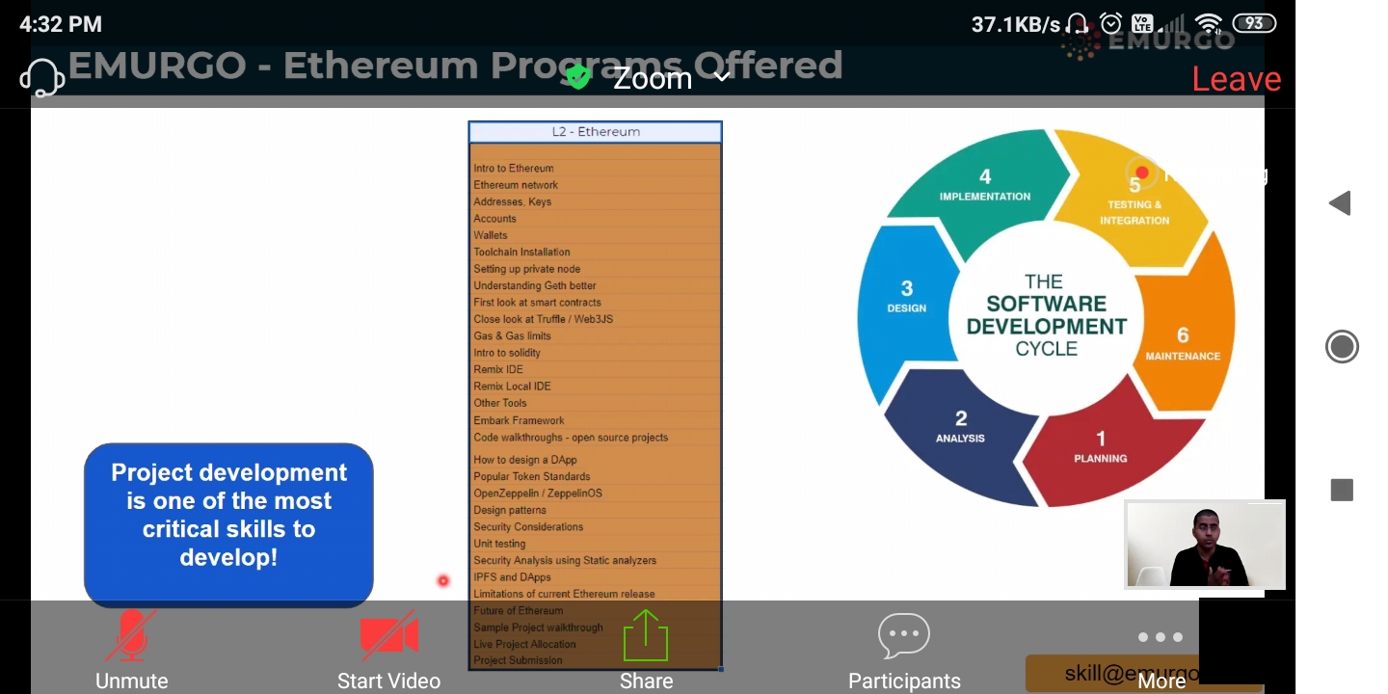

I have started a new course “Application Developer” by AWS Educate. In this course today I learnt about Introduction of software development and its tools. I have successfully completed the first module of this course.

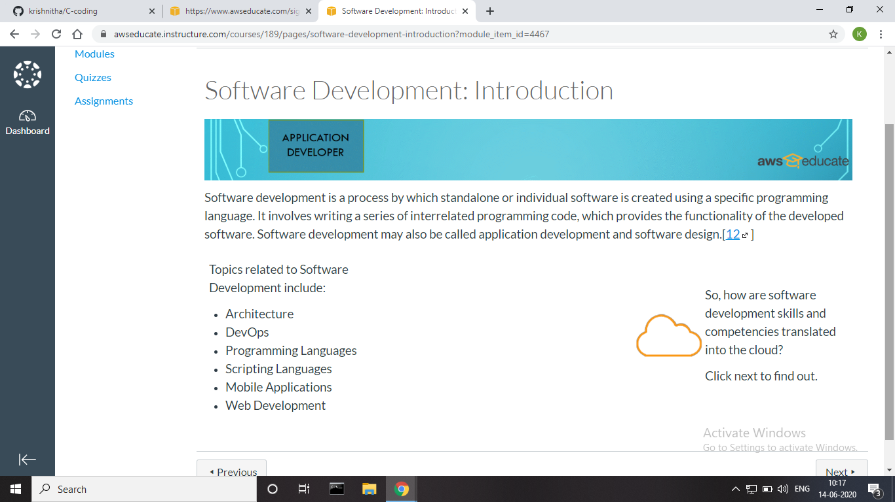

**Coding Challenges Details:**

**Problem 1:** Write a C Program to calculate Electricity Bill

Given an integer U denoting the amount of KWh units of electricity consumed, the task is to calculate the electricity bill with the help of the below charges:  
• 1 to 100 units – Rs 10/- Per Unit  
• 100 to 200 units – Rs. 15/- Per Unit  
• 200 to 300 units – Rs. 20/- Per Unit  
• above 300 units – Rs. 25/- Per Unit

**Examples:**

Input: U = 250

Output: 3500

**Explanation:**

Charge for the first 100 units – 10*100 = 1000*Charge for the 100 to 200 units *– 15*100 = 1500  
Charge for the 200 to 250 units – 20*50 = 1000  
Total Electricity Bill = 1000 + 1500 + 1000 = 3500

**Solution:** Uploaded it in GitHub

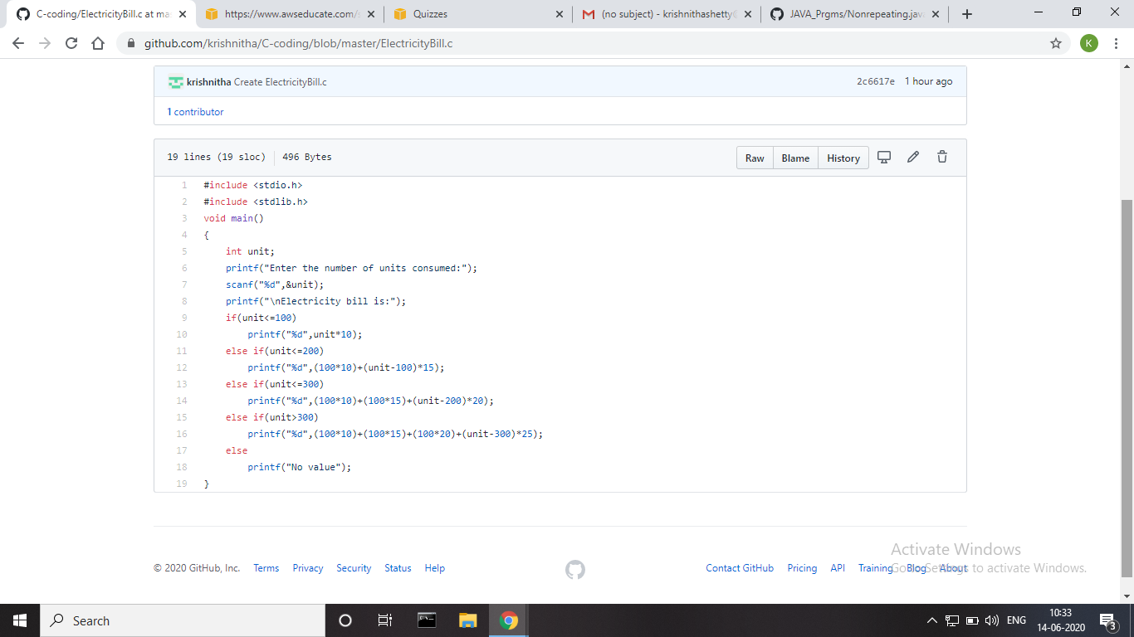

**Problem 2:** Write a program to find the first non-repeated character of a given String.

**Solution:** Uploaded it in GitHub

